**Drone Recording Script/Version 1/2-1-18/by Mitch Pyle**

Gathering accurate data is a crucial part of this project. We need to record the sounds emitted by the drone as soon as possible. Sadly, the drone does not have a long battery life. It can take up to an hour to recharge. In order to make the most of our time in the anechoic room a script seems appropriate. Currently, we have two scripts. One to capture the sound of the drone at varying distances from the microphone, and one to capture the effect of varying the orientation of the microphone array in relation to the drone.

**Distance**

The distance recordings must be accomplished first. This will give us a proper distance for the directional recording. The drone and the microphone array should be set up in such a way to maximize the distance between drone and array. Ideally the drone and the microphone array should be at the same height with the drone perpendicular to the center of the array. Currently we are using two microphones. The distance between the microphones should be recorded. Starting at .5 meters we will move the drone away from the array in .5 meter increments. At each step a 5 second uninterrupted recording should be made.

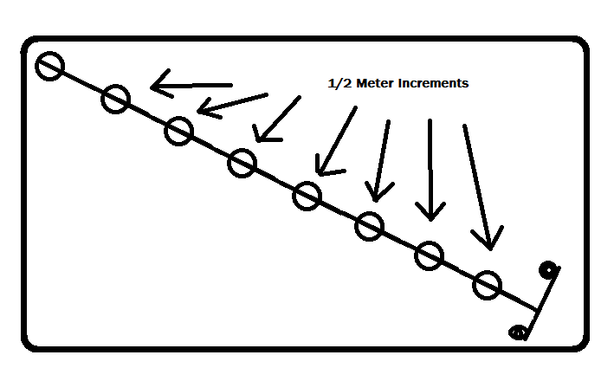

|  |  |  |  |  |
| --- | --- | --- | --- | --- |
| Distance Notes |  |  |  |  |
|  |  |  |  |  |
|  |  |  |  |  |
|  |  |  |  |  |
|  |  |  |  |  |
|  |  |  |  |  |
|  |  |  |  |  |
|  |  |  |  |  |
|  |  |  |  |  |

**Direction**

For this recording the microphone array must be set up where it can rotate freely. The drone and array should be at the same height. The drone should be at the maximum distance possible. This is to be determined from the distance test. 5 recordings should be made. Each recording should again be 5 seconds at least. Starting with the array parallel with the direction of the drone, the array will be turned 45 degrees until again parallel with the direction of the drone.

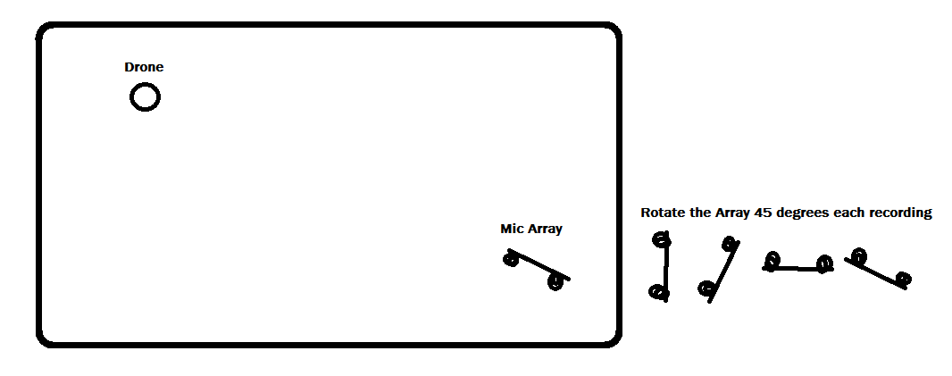

|  |  |  |  |  |
| --- | --- | --- | --- | --- |
| Direction Notes |  |  |  |  |
|  |  |  |  |  |
|  |  |  |  |  |
|  |  |  |  |  |
|  |  |  |  |  |
|  |  |  |  |  |
|  |  |  |  |  |
|  |  |  |  |  |
|  |  |  |  |  |

**Recording Quality**

If we have time a third recording session should attempt to identify the ideal parameters for our recording. The initial recording should capture as much as possible, but later recordings mat lower quality may be helpful in determine the most efficient recording parameters for our purposes.

|  |  |  |  |  |
| --- | --- | --- | --- | --- |
| Distance Notes |  |  |  |  |
|  |  |  |  |  |
|  |  |  |  |  |
|  |  |  |  |  |
|  |  |  |  |  |
|  |  |  |  |  |
|  |  |  |  |  |
|  |  |  |  |  |
|  |  |  |  |  |